**PERSONAL PORTFOLIO WEBSITE:** Project Report

|  |  |  |
| --- | --- | --- |
| **Student Name: Mahak Rana** |  | **UID:24 MCA20156** |
| **Branch: MCA(GENERAL)** |  | **Section/Group:3A** |
| **Semester: 1st** |  | **Date of Performance: 1/11/24** |

**Subject Name: WEB PROGRAMMING LAB Subject Code: 24CAH-605**

## Project Report: Personal Portfolio Website.

## 1.Project Overview

The Personal Portfolio Website serves as a digital showcase for your skills, projects, and contact information. It is designed to provide a clear and engaging representation of your work as a web developer, allowing potential employers or collaborators to learn more about you and your projects.

Purpose:

* To display your professional profile and highlight your technical skills.
* To provide an easy way for others to contact you.
* To feature projects you have worked on, demonstrating your capabilities.

## 2. Features

The website includes the following key sections:

1. Header:

* Contains the title of the portfolio and a profile picture.
* Immediately introduces visitors to who you are.

2. Navigation Bar:

* Provides links to the main sections of the portfolio: About Me, Projects, and Contact.
* Enhances user experience by allowing easy navigation.

3. About Me Section:

* A brief introduction highlighting your background and interests in web development.
* Engages visitors by providing personal insight.

4. Projects Section:

* Lists projects you have completed, each with a brief description.
* Demonstrates your practical experience and technical skills.
* Highlights diverse projects, including those involving Linux and Python.

5. Contact Section:

* Includes your email address for potential inquiries or collaborations.
* Facilitates easy communication.

6. Footer:

- Contains copyright information, giving a professional touch to the website.

## 3. Technologies Used

* HTML: The core structure of the website is built using HTML, allowing for the creation of a well-organized and semantic layout.
* CSS: External styling is referenced for visual design (though the CSS file path uses an absolute local path, which may need to be changed for deployment).
* Images: A personal profile picture is included to create a more relatable and engaging experience.

## 4. Design Considerations

* User Experience: The design is straightforward, making it easy for users to navigate and find information quickly.
* Accessibility: Use of semantic HTML elements helps improve accessibility for screen readers and other assistive technologies.
* Responsive Design: While not explicitly coded in the snippet, ensuring the layout adapts to various screen sizes is crucial for user accessibility.

**5.Code Implementation:**

<!DOCTYPE html>

<html lang="en">

<head>

<meta charset="UTF-8">

<meta name="viewport" content="width=device-width, initial-scale=1.0">

<title>My Portfolio</title>

<link rel="stylesheet" href="styles.css">

</head>

<body>

<header>

<h1>Welcome to My Portfolio</h1>

<img src="images/profile.jpg" alt="Profile Picture" class="profile-img">

</header>

<nav>

<ul>

<li><a href="#about">About Me</a></li>

<li><a href="#projects">Projects</a></li>

<li><a href="#contact">Contact</a></li>

</ul>

</nav>

<section id="about">

<h2>About Me</h2>

<p>Hello! I am a web developer with a passion for creating interactive and user-friendly applications.</p>

</section>

<section id="projects">

<h2>My Projects</h2>

<ul>

<li>Project 1: <a href="#">Description of project 1</a></li>

<li>Project 2: <a href="#">Description of project 2</a></li> <li>Project 3: <a href="#">Description of project 3</a></li>

</ul>

</section>

<section id="contact">

<h2>Contact Me</h2>

<p>Email: <a

href="mailto:example@example.com">example@example.com</a></p>

</section>

<footer>

<p>&copy; 2024 My Portfolio</p>

</footer>

</body>

</html>

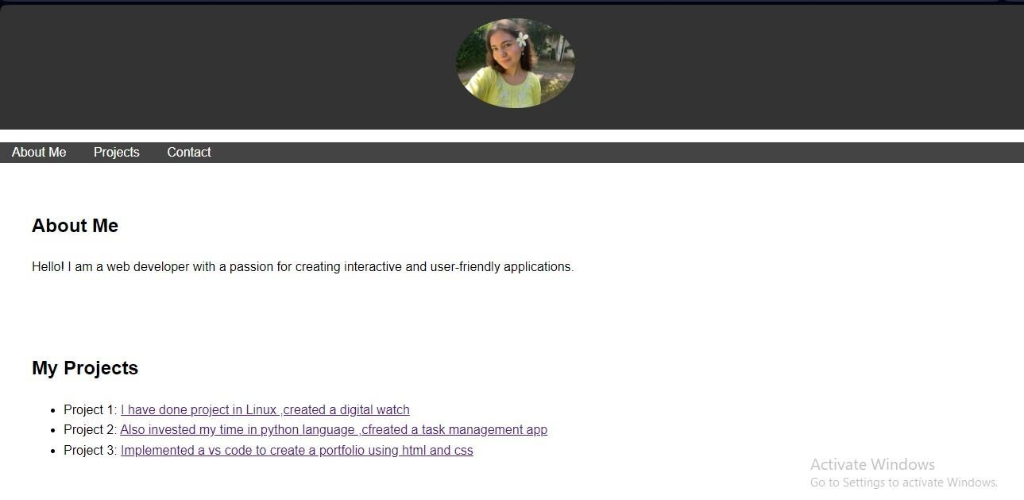

**6. Challenges and Recommendations**  Challenges:

* Absolute File Paths: The use of absolute paths for the CSS and image files (e.g., `C:\Users\user\style.css`) may lead to issues when sharing or deploying the website. These should be changed to relative paths for portability.
* Limited CSS Styling: The report mentions a CSS file, but without its contents, the visual design of the page cannot be assessed. Implementing a cohesive styling strategy is recommended.

Recommendations:

* Relative Paths: Change all file references to relative paths to ensure the website works correctly on different devices and environments.
* Enhanced Styling: Use CSS to improve the layout and visual appeal of the portfolio. Consider using flexbox or grid for layout, and adding hover effects to links for interactivity.
* Responsiveness: Ensure the website is fully responsive by testing it on various devices and adding media queries if necessary.
* Additional Projects: As more projects are completed, update the Projects section to keep the portfolio current and relevant.

## 7. Future Enhancements

* Project Links: Provide direct links to live demos or GitHub repositories for each project listed.
* More Sections: Consider adding sections for testimonials, skills, or a blog to share insights and experiences.
* Social Media Links: Include links to professional social media profiles (e.g., LinkedIn, GitHub) to enhance your online presence.

## 8.Conclusion

The Personal Portfolio Website is a crucial tool for showcasing your skills and projects as a web developer. By addressing the challenges and implementing the recommendations outlined in this report, you can enhance its functionality, usability, and aesthetic appeal, making a stronger impression on visitors.

## 9.References

1. HTML and CSS Basics:

- W3Schools. (n.d.). [HTML Tutorial](https://www.w3schools.com/html/) - W3Schools. (n.d.). [CSS Tutorial](https://www.w3schools.com/css/)

2. Responsive Web Design:

* Mozilla Developer Network (MDN). (n.d.). [Responsive Design](https://developer.mozilla.org/en-

US/docs/Learn/CSS/Building_blocks/Responsive_design)

* Google Developers. (n.d.). [Responsive Web Design

Basics](https://developers.google.com/web/fundamentals/design-andux/responsive)

3. Web Accessibility:

* W3C Web Accessibility Initiative. (n.d.). [Introduction to Web

Accessibility](https://www.w3.org/WAI/fundamentals/accessibility-intro/)

* WebAIM. (n.d.). [Web Accessibility

Guidelines](https://webaim.org/articles/guidelines/)

4. Best Practices for Portfolio Websites:

* Smashing Magazine. (2019). [How to Create a Portfolio That Gets You Hired](https://www.smashingmagazine.com/2019/05/create-portfoliowebsite/)
* CareerFoundry. (n.d.). [How to Build a Portfolio

Website](https://careerfoundry.com/en/blog/web-development/how-tobuild-a-portfolio-website/)

5. CSS Design Techniques:

* CSS Tricks. (n.d.). [A Complete Guide to Flexbox](https://csstricks.com/snippets/css/a-guide-to-flexbox/)
* CSS Tricks. (n.d.). [A Complete Guide to Grid](https://csstricks.com/snippets/css/complete-guide-grid/)